**Find module:**

* Return a list of files based on specific criteria. Multiple criteria are AND’d together.
* For Windows targets, use the win_find module instead.

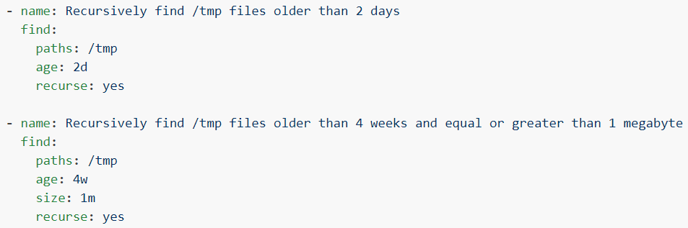

* Finding older files in a directory.

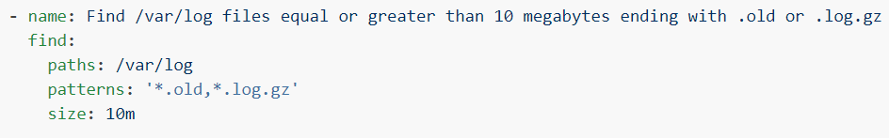

* Finding the file that are ending with **“.log”** or **“.log.gz”** with equal or greater than 10 MB of size.

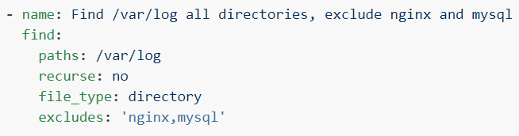

* Finding all the directories inside the give path by excluding “nginx” and “mysql”

**Options:**

**contains**



* It will show the files if the given content is matched with the data inside the file.

**hidden**

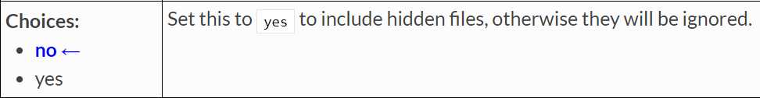

**Lineinfile module:**

* This module ensures a particular line is in a file, or replace an existing line using a back-referenced regular expression.
* This is primarily useful when you want to change a single line in a file only.
* See the replace module if you want to change multiple, similar lines or check blockinfile if you want to insert/update/remove a block of lines in a file. For other cases, see the copy or template modules

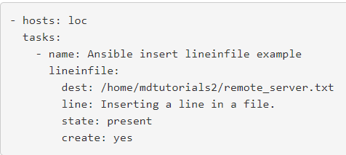

* As above, we can insert new line at the end of the file.
* If line already exists, then it won’t add again. if we give **“create=yes”**, then it will create the file if it doesn’t exist and add the line

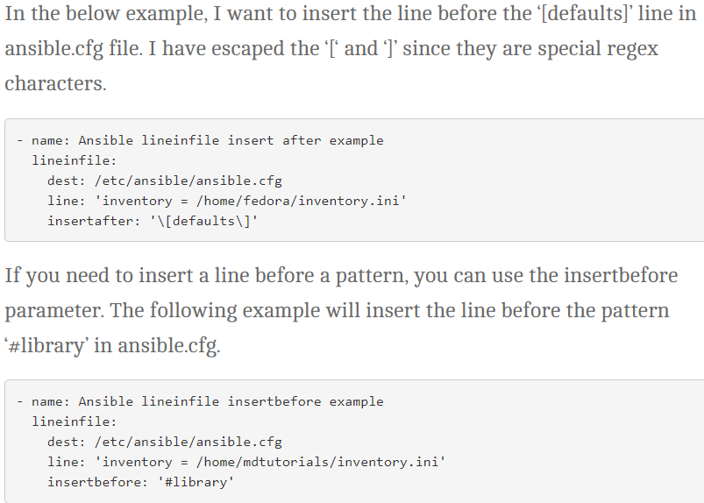

* Above is the example to add a line using **“insertbefore”** and **“insertafter”** arguments.

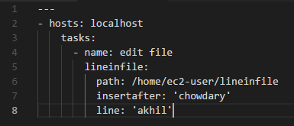

* If the line is already existing, then it skips the step

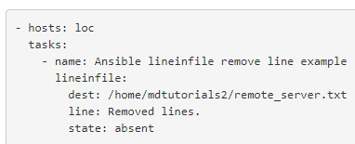

* Below example to remove the line

**Options:**

**backup**

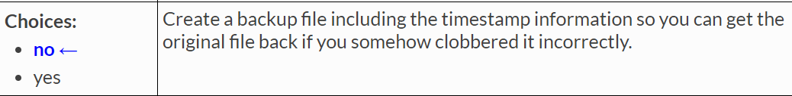

* If we enable this option, a backup file will be created with timestamp before changing the file.

**create**

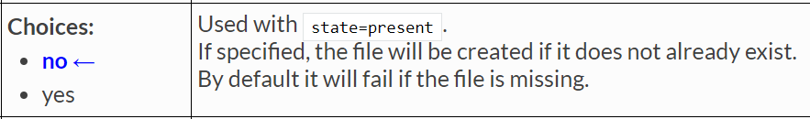

* It will create the file if it doesn’t exist when we give the value as **“yes”.**

**mode**

* we can use **“mode”** option here as well to give the permissions to the file.

**owner**

* **“owner”** option can also be used here to change the ownership of a file.

**state**

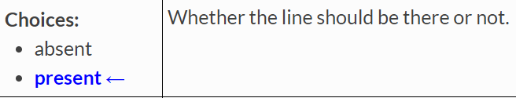

* We can use this option if we want to delete a line. No need to use **“present”** option to insert a line as the default value is “present”

**Replace module:**

* This module will replace all instances of a pattern within a file.
* It is up to the user to maintain idempotence by ensuring that the same pattern would never match any replacements made

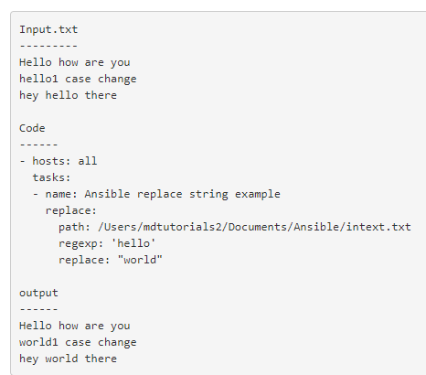

* Replace of multiple strings with same variable

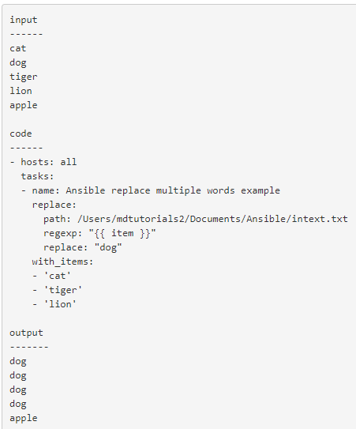

* Removing a particular string

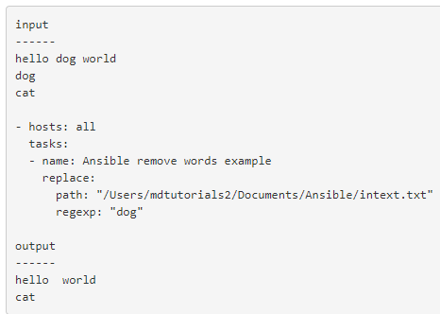

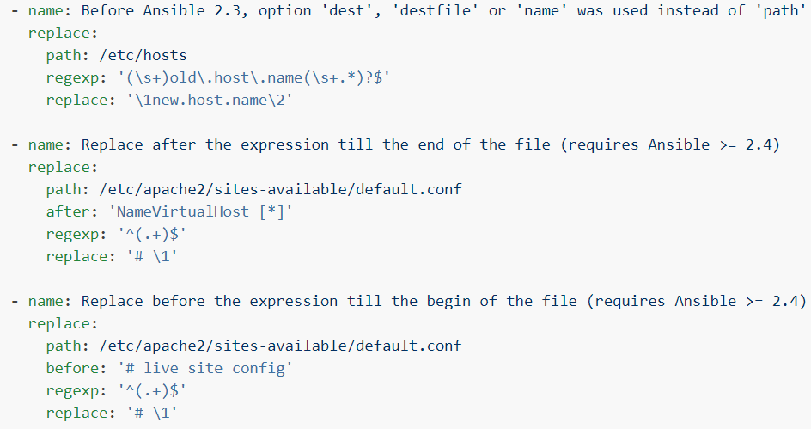

**Options:**

**after**

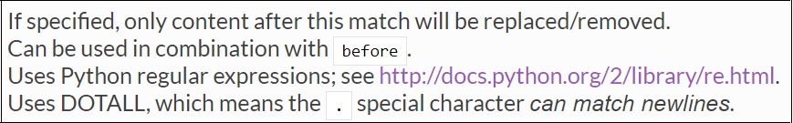

**before**

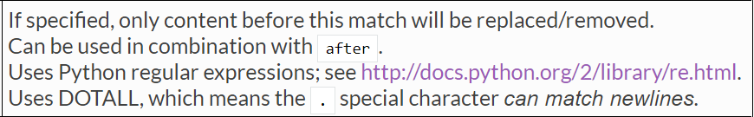

* **“group”,** **“mode”** & **“owner”** options are also there.